

**BANGLADESH UNIVERSITY OF BUSINESS & TECHNOLOGY**

**(BUBT)**

MIRPUR-2, DHAKA

**Railway Reservation System**

DEPARTMENT OF COMPUTER SCIENCE & ENGINEERING.

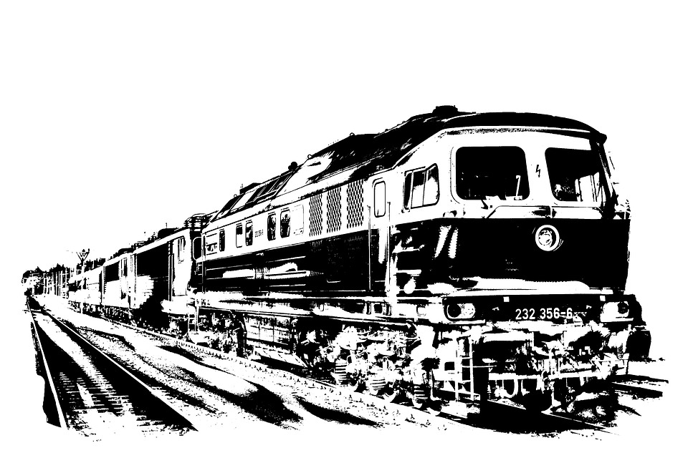

**June, 2019**

**Railway Reservation System**

*A project*

*Submitted to the Department of Computer Science and Engineering*

*Bangladesh University of Business and Technology (BUBT), Dhaka*

*in partial fulfillment of requirements*

*for the software development -1 project*

*of*

**Bachelor of Science**

**in**

**Computer Science and Engineering.**

**By:**

**Syeda Nowshin Ibnat(ID:17183103020)**

**Mahmuda Begum(ID:17183103030)**

**Fatema-Tuz Zohra(ID:17183103009)**

**Intake-39(Sec-1)**

**Supervised by:**

**M. M. Fazle Rabbi**

Assistant professor,

Department of Computer Science and Engineering (CSE)

Bangladesh University of Business and Technology (BUBT)

Mirpur-2, Dhaka-1216, Bangladesh

**ABSTRACT**

The Railway Reservation System facilitates the passengers to enquire about the trains available on the basis of booking and cancellation of tickets, enquire about the status of the booked ticket, etc. The aim of case study is to design and develop a system maintaining the records of different trains, train status, and passengers. The users can directly choose from the option provided such as book a ticket, cancel a ticket, etc.

This project contains introduction to the Railways reservation system. It is a simple system of reserving the seats of train. It is mainly used for long route. In our country, there are number of counters for the reservation of the seats and one can easily make reservation and get tickets. Then this project contains entity relationship model diagram based on railway reservation system. There is also design of the railway reservation system and flow charts. Also there are different modules for railway reservation system.

**DECLARATION**

We hereby declare that the project entitled “**Railway Reservation System**” submitted in partial fulfillment by us for the software development -1 project in the faculty of Computer Science and Engineering of **Bangladesh University of Business and Technology (BUBT)** under the guidance of our supervision of **MR. M. M. Fazle Rabbi,** Assistant professor, department of Computer Science and Engineering. It is our own work and it contains no material which has been accepted for the award to the candidates of any other disciplines expect few references which is taken from various books and authors to enrich our knowledge about the topic of our project.

**--------------------------------**

Syeda Nowshin Ibnat

ID:17183103020

Intake: 39

**--------------------------**

Mahmuda Begum

ID: 17183103030

Intake: 39

**---------------------------**

Fatema-Tuz Zohra

ID: 17183103009

Intake: 39

**Certificate**

To Whom It May Concern

That is to certify that Syeda Nowshin Ibnat, Mahmuda Begum and Fatema-Tuz Zohra students of B.Sc. in CSE has completed their software development-1 project work titled **“Railway Reservation System** “satisfactorily in partial fulfillment for the requirements of B.Sc. in Computer Science and Engineering from Bangladesh University of Business and Technology in the year June, 2019.

**---------------------------**

Fatema-Tuz Zohra

ID: 17183103009

Intake: 31

**--------------------------------**

Syeda Nowshin Ibnat

ID: 17183103020

Intake: 31

**--------------------------**

Mahmuda Begum

ID: 17183103030

Intake: 31

---------------------------------------------------------------

**Project Supervisor**

**M. M. Fazle Rabbi**

~~Lecturer~~,

Department of CSE,

Bangladesh University of Business and Technology (BUBT).

Mirpur-2, Dhaka-1216.

---------------------------------------------------------------

**Project Supervisor**

**M. M. Fazle Rabbi**

Assistant professor

Department of CSE,

Bangladesh University of Business and Technology (BUBT).

Mirpur-2, Dhaka-1216.

**Dedication**

***Dedicated to our parents for all their love and inspiration.***

**Acknowledgement**

“Task successful” makes everyone happy. But the happiness will be gold without glitter if we didn’t state the persons who have supported us to make it a success. Success will be crowned to people who made it a reality but the people whose constant guidance and encouragement made it possible will be crowned first on the eve of success.

This acknowledgment transcends the reality of formality when we would like to express deep gratitude and respect to all those people behind the screen who guided, inspired and helped us for the completion of our project work. We consider ourselves lucky enough to get such a good project. This project would add as an asset to our academic profile.

We express our gratitude to the help of our supervisor **Mr. M. M. Fazle Rabbi**, for his constant supervision, guidance and co-operation throughout the project and for giving constant motivation and valuable help through the project work. We also would like to thanks to our honorable chairman **Prof. Dr. M. Ameer Ali,** for his support and giving us support and giving us permission to use the computer lab whenever we needed.

We extend our sincere gratitude to our parents who have encouraged us with their blessings to do this project successfully. Finally, we would like to thank to all our friends, all the teaching and non-teaching staff members of the CSE Department, for all the timely help, ideas and encouragement which helped throughout in the completion of project.

**Approval**

This project “**Railway Reservation System**” submitted by **Syeda Nowshin Ibnat**, **Mahmuda**

**Begum** and **Fatema-Tuz Zohra** ID No. **17183103020, 17183103030** and **17183103009** students of B.Sc. in Computer Science and Engineering from Bangladesh University of Business and Technology in the year june,2019 under the supervision of **M. M. Fazle Rabbi,**Assistant Professor Department of Computer Science and Engineering has been accepted as satisfactory for the partial fulfillment for the requirements of B.Sc. in Computer Science and Engineering and approved as to its style and contents.

---------------------------------------------------------------

**Project Supervisor**

**M. M. Fazle Rabbi**

~~Lecturer~~,

Department of CSE,

Bangladesh University of Business and Technology (BUBT).

Mirpur-2, Dhaka-1216.

---------------------------------------------------------------

**Project Supervisor**

**M. M. Fazle Rabbi**

Assistant professor

Department of CSE,

Bangladesh University of Business and Technology (BUBT).

Mirpur-2, Dhaka-1216.

**--------------------------------**

**Chairman:**

|  |  |
| --- | --- |
| |  | | --- | | **Prof. Dr. M. Ameer Ali** | |

Professor and Chairman

Department of Computer Science and Engineering (CSE)

Bangladesh University of Business and Technology (BUBT)

Mirpur-2, Dhaka-1216, Bangladesh

**Copyright**

© Copyright by Syeda Nowshin Ibnat(17183103020),

Mahmuda Begum (17183103030), and Fatema-Tuz Zohra(17183103009)

All Right Reserved

# Abbreviations

|  |  |
| --- | --- |
| **Synonyms and Acronyms**  C | **Descriptions**  Structured Programming Language |
| RAM | Random Access Memory |

DFD Data Flow Diagram

**Table of Contents**

***Page No***

**Abstract…………………………………………………………………………………….. iii**

**Declaration……………………………………………………………………………… .iv**

**Certificate…………………………………………………………………………………….. v**

**Dedication…………………………………………………………………………………… .vi**

**Acknowledgement ……………………...…………………………………………………… vii**

**Approval……………………………………………………………………………..............viii**

**Copyright……………………………………………………………………………..............ix**

**Abbreviations……………………...………………………………………………………….x**

**Chapter-1: Introduction……………………………………………………..........................1-5**

1.1 Introduction……………….................…………. . …………1

1.2 Problem Statement…………………………………………………. . ................1

1.3 Motivation………………………………………………………………. ………................2

1.4 Objectives…………………………………………………….....................….. ...................3

1.5 Contributions................................................................................................ .........................4 1.6 Organization of Project Report…………………………………… ......................................5

1.7 Conclusions................................................................................................ ........................ ..5

**Chapter-2: Existing System..................................................................................................7-12**

2.1 Introduction……………………………………………………………………………… 7

2.2 Existing System………………………………………………………………………….. 7

2.3 Used Diagram……………………………………………………………………….. 8

2.3.1 Use Case Diagram………………………………………………………………… 9

2.3.2 Data Flow Diagram……………………………………………………….................. 9

2.3.3 ER Diagram ………………………………………………………..................... 10

2.4 Technology Used………………………………………………………..................... 12

2.4.1 Code Editor ………………………………………………………………… 12

2.5 Conclusions………………………………………………………………………… 12

**Chapter-3: Proposed Model................................................................................................13-27**

3.1 Introduction……………………………………………………………………… 13

3.2 Feasibility Study………………………………………………………………………… 13

3.2.1 Technical Feasibility…………………………………………………………… ....14

3.2.2 Operational Feasibility…………………………………………………………… 14

3.2.3 Economical Feasibility…………………………………………………………….. .15

3.3 Non-Functional Requirement……………………………………………………… .15

3.3.1 Performance Requirements………………………………………………………... 15

3.3.2 Logical Requirements…………………………………………………… 16

3.3.3 Design Constraints……………………………………………………………… 16

3.3.4 Security………………………………………………………………………......... 17

3.3.5 Maintainability……………………………………………………………………... 17

3.4 Functional Requirements……………………………………………………………… 17

3.5 System Design…………………………………………………………………………. 18

3.5.1 Using Waterfall Model………………………………………………………… 18

3.5.2 Flow Chart…………………………………………………………………………. 19

3.5.3 Use Case Diagram…………………………………………………………………. 23

3.5.3.1 Use Case Diagram for Admin……………………………………………… 23

3.5.3.2 Use Case Diagram for User………………………………………………… 24

3.6 Flow Chart for Admin……………………………………………………………………25

3.7 User Modules………………………………………………………………………… 26

3.8 Admin Panel..................................................................................................... 27

3.9 Conclusions………………………………………………………………………… 27

**Chapter-4: Experimental Result......................................................................................28-32**

4.1 Introduction.......................................................................................................................28

4.2 Testing of Various Function.............................................................................................28

4.3 Result Analysis..................................................................................................................29

4.3.1 Unit Test Cases.............................................................................................................29

4.3.2 Test Scenario................................................................................................................30

4.4 Test Cases..........................................................................................................................30

4.4.1 Test Case of ticket Booking..........................................................................................31

4.5 Application Outcome.........................................................................................................32

4.6 Conclusions........................................................................................................................32

**Chapter-5: User Manual.....................................................................................................34-43**

5.1Introduction........................................................................................................... ......34

5.2 System Requirements................................................................................................... ......34

5.2.1 Hardware Requirements......................................................................................... ......34

5.2.2 For Clients Side................................................................................................... ......35

5.2.3 Software Requirements......................................................................................... ........ 35

5.2.4 For User Side................................................................................................. ......... 35

5.2.5 User Interfaces.......................................................................................................... .....35

5.3 Admin Site........................................................................................................... ..........36

5.4 User Side ............................................................................................................ ....... .40

5.5 Conclusions.............................................................................................................. ..........43

**Chapter-6: Conclusions and Future Plan...................................................... ………............44-47**

6.1 Conclusions................................................................................ .........44

6.2 Future Plan................. ......45

**References.................................................................................................................................46**

**Appendix...................................................................................... …......................................47**

**List of Tables**

4.1 Test Scenario............................................................................................... ......31

4.2 Test Case of Ticket Booking............................................................................... 32

**List of Figures**

1. Use Case Diagram............................................................................................... ......9
2. Data Flow Diagram............................................................................................... ......9
3. ER diagram............................................................................................... ......11
4. Waterfall Model............................................................................................... ......19
5. Flow Chart............................................................................................... .......21
6. Use Case Diagram for Admin.......................................................................................24
7. Use Case Diagram for User...........................................................................................25
8. Admin implementation............................................................................................... ..26
9. Showing Error Message............................................................................................... .30
10. Admin Login Page............................................................................................... ..36
11. Add Train............................................................................................... ...37
12. Cancelled Tickets............................................................................................... .....38
13. All Passengers List............................................................................................... ......39
14. User Menu............................................................................................... ..40
15. Searching Tickets ............................................................................................... ...42